EXPERIMENT-6
6.Realize the system with difference equation
in Cascade and Parallel form

H(z)= 1+0.6z⁻¹+0.08z⁻²​/1−0.9z⁻¹+0.2z⁻²

Given the transfer function of an IIR system, obtain its difference equation and realize the system in both Cascade and Parallel forms. Draw the corresponding block diagrams and verify the realizations (10) (BL3) (WK4)

7.Design a Chebyshev Filter using Bilinear Transformation.he desired magnitude response should satisfy 0.6 ≤ |H (ejw)| ≤1, 0 ≤ ω ≤ π /2
and |H (ejw)| ≤0.1, 3π /4≤ ω ≤ π. Verify ∣H(ejω)at the band edges, determine the pole locations, and comment on the stability of the designed filter. (10) (BL6) W(K5)

8.Designing a Digital Butterworth filter using Bilinear Transformation that satisfies specific frequency response specifications. The desired magnitude response should meet the conditions (10) (BL6) (wK5)
0.95≤∣H(ejω)∣≤1, 0≤ω≤0.25π
∣H(ejω)∣≤0.15, 0.45π≤ω≤π
with a sampling period T=0.5T=0.5 sec. Use the Bilinear Transformation method to design the filter and obtain the digital transfer function H(z)

9.Implement a system governed by the difference equation: y(n)=−0.5y(n−1)+0.72y(n−2)+0.6y(n-3)+0.7x(n)−0.2x(n−2) in Direct Form-I,Direct Form-II Form and Cascade and Parallel Form. (10) (BL4) (wK4)

10.Implement a system governed by the difference equation: y(n)=−0.1y(n−1)+0.72y(n−2)+0.7x(n)−0.25x(n−2) in Direct Form-I,Direct Form-II Form parallel and Cascade Form (10) (BL4) (WK4)

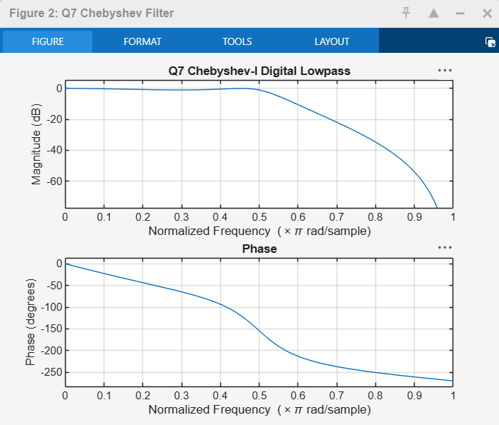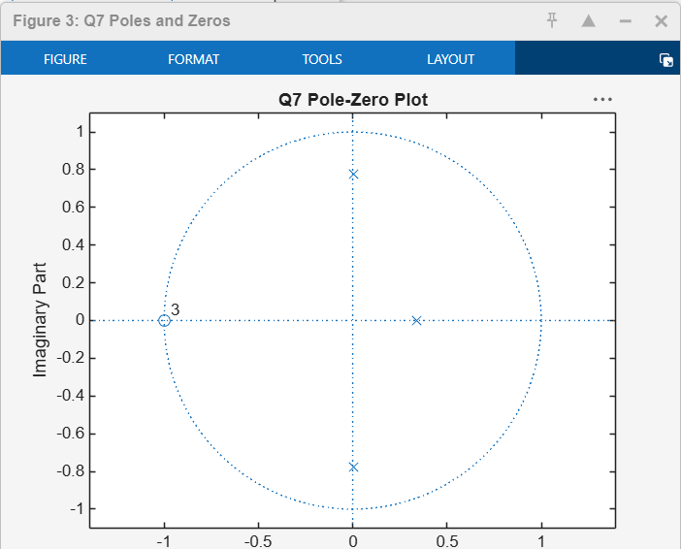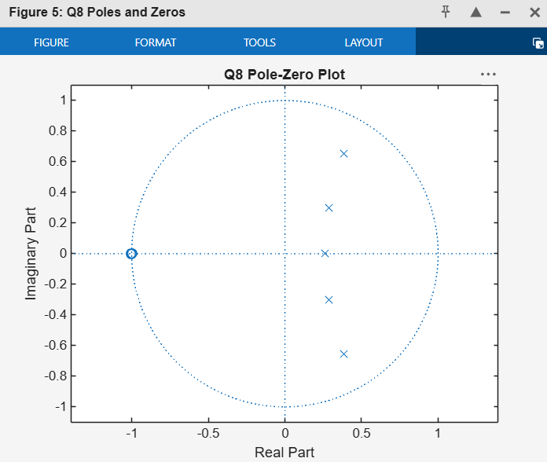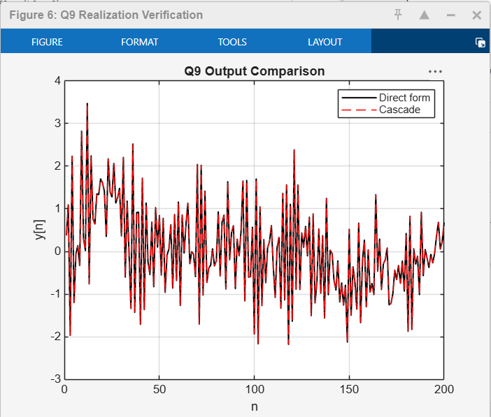

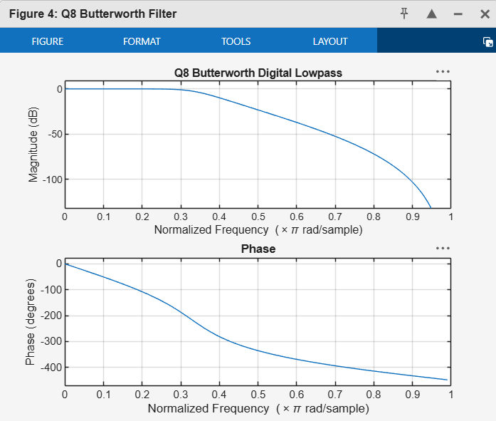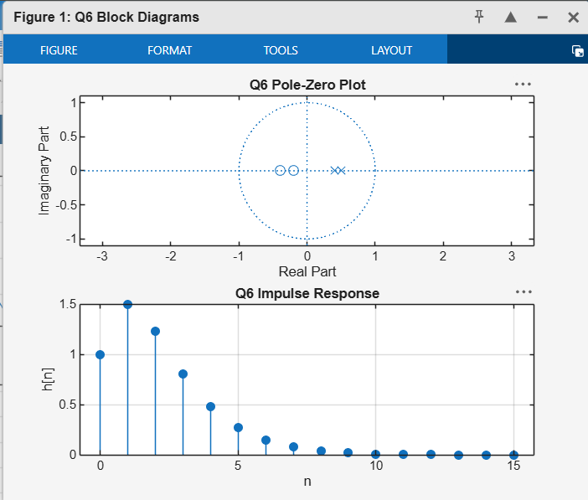

%% Questions 6-10: IIR system realizations and filter design
clear; close all; clc;

%% Q6. Cascade and parallel realization
% H(z) = (1 + 0.6z^-1 + 0.08z^-2) / (1 - 0.9z^-1 + 0.2z^-2)
b6 = [1 0.6 0.08];
a6 = [1 -0.9 0.2];

fprintf('Q6 difference equation:\n');
fprintf('y[n] - 0.9y[n-1] + 0.2y[n-2] = x[n] + 0.6x[n-1] + 0.08x[n-2]\n');
fprintf('So y[n] = 0.9y[n-1] - 0.2y[n-2] + x[n] + 0.6x[n-1] + 0.08x[n-2]\n');

% Cascade form (second-order sections)
[sos6, g6] = tf2sos(b6, a6);
disp('Q6 cascade SOS:');
disp(sos6);
fprintf('Q6 cascade overall gain = %.6g\n', g6);

% Parallel form using partial fractions
[r6, p6, k6] = residuez(b6, a6);
disp('Q6 parallel residues:'); disp(r6);
disp('Q6 parallel poles:'); disp(p6);
disp('Q6 direct polynomial term:'); disp(k6);

% Verification by comparing impulse responses
x = [1 zeros(1,39)];
yDirect6 = filter(b6, a6, x);

% Reconstruct cascade response from SOS
yCascade6 = g6 * x;
for i = 1:size(sos6,1)
yCascade6 = filter(sos6(i,1:3), sos6(i,4:6), yCascade6);
end

fprintf('Q6 maximum direct/cascade error = %.3g\n', ...
max(abs(yDirect6 - yCascade6)));

figure('Name','Q6 Block Diagrams');
subplot(2,1,1);
zplane(b6,a6); title('Q6 Pole-Zero Plot');
subplot(2,1,2);
stem(0:15,yDirect6(1:16),'filled'); grid on;
title('Q6 Impulse Response'); xlabel('n'); ylabel('h[n]');

% Block-diagram layout for cascade: connect SOS sections in series.
% Parallel: connect residue branches and the direct term k6 in parallel.
% Use the printed SOS and residue/pole values to label each section.

%% Q7. Chebyshev-I lowpass filter via bilinear transformation
% Passband: 0 <= w <= pi/2, minimum magnitude 0.6
% Stopband: 3pi/4 <= w <= pi, maximum magnitude 0.1
% Assumption: passband ripple Rp = 1 dB (not stated in question).
Rp7 = 1;
Rs7 = -20*log10(0.1);

Wp7 = pi/2; % digital passband edge, rad/sample
Ws7 = 3*pi/4; % digital stopband edge, rad/sample
T7 = 1; % normalized sampling period

% Prewarp digital frequencies for the bilinear transformation
OmegaP7 = (2/T7)*tan(Wp7/2);
OmegaS7 = (2/T7)*tan(Ws7/2);

[N7, Wn7] = cheb1ord(OmegaP7, OmegaS7, Rp7, Rs7, 's');
[bA7, aA7] = cheby1(N7, Rp7, Wn7, 's');
[b7, a7] = bilinear(bA7, aA7, 1/T7);

fprintf('\nQ7 Chebyshev-I order = %d\n', N7);
disp('Q7 digital numerator b7 ='); disp(b7);
disp('Q7 digital denominator a7 ='); disp(a7);

% Check magnitude at requested band edges
wCheck7 = [pi/2, 3*pi/4];
Hcheck7 = freqz(b7,a7,wCheck7);
fprintf('Q7 |H(e^jw)| at pi/2 = %.6f\n', abs(Hcheck7(1)));
fprintf('Q7 |H(e^jw)| at 3pi/4 = %.6f\n', abs(Hcheck7(2)));

% Poles and stability
poles7 = roots(a7);
disp('Q7 digital poles:'); disp(poles7);
fprintf('Q7 stable (all poles inside unit circle): %d\n', all(abs(poles7)<1));

figure('Name','Q7 Chebyshev Filter');
freqz(b7,a7,1024); title('Q7 Chebyshev-I Digital Lowpass');
figure('Name','Q7 Poles and Zeros');
zplane(b7,a7); title('Q7 Pole-Zero Plot');

%% Q8. Butterworth lowpass filter via bilinear transformation
% Passband: 0 <= w <= 0.25pi, magnitude >= 0.95
% Stopband: 0.45pi <= w <= pi, magnitude <= 0.15
T8 = 0.5; % sampling period in seconds
Wp8 = 0.25*pi; % rad/sample
Ws8 = 0.45*pi; % rad/sample
Rp8 = -20*log10(0.95);
Rs8 = -20*log10(0.15);

% Prewarp frequencies (digital radians/sample -> analog rad/sec)
OmegaP8 = (2/T8)*tan(Wp8/2);
OmegaS8 = (2/T8)*tan(Ws8/2);

[N8, Wn8] = buttord(OmegaP8, OmegaS8, Rp8, Rs8, 's');
[bA8, aA8] = butter(N8, Wn8, 's');
[b8, a8] = bilinear(bA8, aA8, 1/T8);

fprintf('\nQ8 Butterworth order = %d\n', N8);
disp('Q8 digital transfer function numerator b8 ='); disp(b8);
disp('Q8 digital transfer function denominator a8 ='); disp(a8);

Hcheck8 = freqz(b8,a8,[Wp8 Ws8]);
fprintf('Q8 |H| at passband edge = %.6f (must be >= 0.95)\n',abs(Hcheck8(1)));
fprintf('Q8 |H| at stopband edge = %.6f (must be <= 0.15)\n',abs(Hcheck8(2)));

poles8 = roots(a8);
disp('Q8 digital poles:'); disp(poles8);
fprintf('Q8 stable (all poles inside unit circle): %d\n', all(abs(poles8)<1));

figure('Name','Q8 Butterworth Filter');
freqz(b8,a8,1024); title('Q8 Butterworth Digital Lowpass');
figure('Name','Q8 Poles and Zeros');
zplane(b8,a8); title('Q8 Pole-Zero Plot');

%% Q9. Direct Form-I, Direct Form-II, cascade and parallel
% y[n] = -0.5y[n-1] + 0.72y[n-2] + 0.6y[n-3]
% + 0.7x[n] - 0.2x[n-2]
% Move output terms to the left side to get A(z)Y(z) = B(z)X(z).
b9 = [0.7 0 -0.2];
a9 = [1 0.5 -0.72 -0.6];

fprintf('\nQ9 transfer function:\n');
disp('B9 ='); disp(b9);
disp('A9 ='); disp(a9);

% Direct Form I and II are represented by the same transfer function
% coefficients in MATLAB's filter implementation.
x9 = randn(1,200);
y9_DFI = filter(b9,a9,x9);
y9_DFII = filter(b9,a9,x9);

% Cascade
[sos9,g9] = tf2sos(b9,a9);
y9_cascade = g9*x9;
for i = 1:size(sos9,1)
y9_cascade = filter(sos9(i,1:3),sos9(i,4:6),y9_cascade);
end

% Parallel decomposition (residue expansion)
[r9,p9,k9] = residuez(b9,a9);
disp('Q9 parallel residues:'); disp(r9);
disp('Q9 parallel poles:'); disp(p9);
disp('Q9 parallel direct term:'); disp(k9);

% Verify cascade response against direct form
fprintf('Q9 maximum direct/cascade error = %.3g\n', ...
max(abs(y9_DFI-y9_cascade)));
fprintf('Q9 maximum DFI/DFII error = %.3g\n', ...
max(abs(y9_DFI-y9_DFII)));

figure('Name','Q9 Realization Verification');
plot(y9_DFI,'k','LineWidth',1.2); hold on;
plot(y9_cascade,'r--');
grid on; legend('Direct form','Cascade');
title('Q9 Output Comparison'); xlabel('n'); ylabel('y[n]');

% Draw the structures using printed coefficients:
% Direct Form I: separate input delay line for b9 and output delay line for a9.
% Direct Form II: one shared delay line.
% Cascade: serial SOS sections from sos9 with gain g9.
% Parallel: sum branches specified by r9, p9, and direct term k9.

%% Q10. Direct Form-I, Direct Form-II, parallel and cascade
% y[n] = -0.1y[n-1] + 0.72y[n-2] + 0.7x[n] - 0.25x[n-2]
b10 = [0.7 0 -0.25];
a10 = [1 0.1 -0.72];

fprintf('\nQ10 transfer function:\n');
disp('B10 ='); disp(b10);
disp('A10 ='); disp(a10);

x10 = randn(1,200);
y10_DFI = filter(b10,a10,x10);
y10_DFII = filter(b10,a10,x10);

% Cascade form using second-order sections
[sos10,g10] = tf2sos(b10,a10);
y10_cascade = g10*x10;
for i = 1:size(sos10,1)
y10_cascade = filter(sos10(i,1:3),sos10(i,4:6),y10_cascade);
end

% Parallel form
[r10,p10,k10] = residuez(b10,a10);
disp('Q10 parallel residues:'); disp(r10);
disp('Q10 parallel poles:'); disp(p10);
disp('Q10 parallel direct term:'); disp(k10);

fprintf('Q10 maximum direct/cascade error = %.3g\n', ...
max(abs(y10_DFI-y10_cascade)));
fprintf('Q10 maximum DFI/DFII error = %.3g\n', ...
max(abs(y10_DFI-y10_DFII)));

figure('Name','Q10 Realization Verification');
plot(y10_DFI,'k','LineWidth',1.2); hold on;
plot(y10_cascade,'b--');
grid on; legend('Direct form','Cascade');
title('Q10 Output Comparison'); xlabel('n'); ylabel('y[n]');

% Draw the requested diagrams using:
% Direct Form I: numerator and denominator delay lines.
% Direct Form II: shared delay line.
% Cascade: serial SOS sections from sos10 with gain g10.
% Parallel: parallel residue branches from r10 and p10, plus k10.

